**1.Abstract**

A big challenge in the urban cities is that of waste management as there is a rapid growth in the rate of urbanization and thus there is a need of sustainable urban development plans. As the concept of smart cities is very much trending these days and the smart cities cannot be complete without smart waste management system. There needs to be system that gives prior information of the filling of the bin that alerts the municipality so that they can clean the bin on time and safeguard the environment. To avoid all such situations we intend to propose a solution for this problem "Smart Garbage Bin", which will alarm and inform the authorized person when the garbage bin is about to fill. Then message will be send to the authorized person to collect the garbage from the particular area. The authorized person will sends the message from his web application to the garbage collectors by sending a SMS .This system maintain a dry waste and a wet waste separately. This will help to reduce the overflow of the garbage bin and thus keeping the environment clean.

Keywords— Smart Garbage bins, IOT, Waste

**2.Litreature Survey**

Waste management is an essential part of maintaining a city’s hygiene and health. Developed countries now have adequate resources and equipment to sustain these favorable conditions, such as up-to-date and even real-time waste generation statistics, qualified personnel, and current fleets of collection trucks equipped with the most cutting-edge technical breakthroughs or instruments, such as geographical information systems. Finally, collection routes and the number of trucks required for each waste proportion in each region were estimated. All of this activities contribute to the solution of the waste disposal problem in a single zone where immediate solutions are required to advance toward sustainable development . However, these garbage collecting methods have contributed to sustainability by reducing trash, pollution, and expenses while also enhancing the quality of recovered garbage. Thus, industrialized economies should take note of how trash collection methods have affected resource recovery. the construction of buyback centers should be prioritized in emerging nations, where the majority of garbage is retrieved informally. 'e influence of buy-back centers on resource recovery should be examined in a future study on establishing recovery programs in emerging countries. The quantity of reusable, recyclable, and remanufactured garbage collected from the informal waste sector should be factored in. As a result of the curbside component in the preimplemented system, the mixed collection system has more excellent material separation rates, better recycling rates, and lower contamination rates than the exclusive drop-off system . Furthermore, attempts to reduce waste had a substantial impact on just recycling behavior. However, attitudes toward resource efficiency had a negligible impact on all waste management behaviors, indicating that individuals in the European Union (EU) are unaware of the link between waste reduction and resource efficiency . Transportation of garbage (typically over long distances and with high frequency) to large processing facilities and the Computational Intelligence and Neuroscience complicated waste separation systems necessary are the weakest points of centralized waste management systems. Both consume much energy and contribute to the worsening of climate change. Garbage treatment in homes allows for the elimination of the inconvenient nature of extended waste management systems. Several waste management techniques may be used at home, depending on the amount of space, time, and financial resources available to the householders. Unfortunately, most of them (composting, anaerobic digestion, and open burning) can only handle organic waste. Composting is the most frequent waste management technology at the household level. There are various processes and types of equipment available, ranging from simple homemade boxes to more advanced but more expensive automated composters. Composting allows the nutrients in the biomass to be returned to the soil. Consumers can get high-quality fertilizer. It will, however, take time. Furthermore, microbes use the energy present in the waste. It is lost from the standpoint of residents . The system designed in this research is based on a prototype of IoT sensing. It monitors the garbage level in the garbage bins and sends the data to a server for storage and processing (through the Internet). This information is used to calculate the best collecting routes for the personnel. We would aim to improve the system in the future for diverse types of garbage, such as solid and liquid wastes . The smart garbage bins are monitored in real time by the IoT based garbage collection system . It allows a user to keep track of the garbage bins’ fill level, fill status, volatile organic compounds (VOC) level, temperature, and humidity from anywhere at any time. It also identifies which garbage containers should be emptied at the end of each collection cycle. In addition, the navigation system suggests the best driving routes for collecting rubbish from the designated containers. 'e technology reduces travel distance significantly as compared to the previous approach, resulting in a more efficient garbage collecting procedure and lower costs . Finally, the authors think that their work has contributed to waste management since it is a valuable tool for technical personnel who may develop and enhance a town’s garbage collecting system . The authors suggested a unique municipal solid waste (MSW) collection optimization model based on the actual real-world trash-collecting scenario in Sfax and then used the new innovative routing method for MSW collection. Throughout the study, all of the approaches have been explicitly presented . In a previous research, an optimum path planning algorithm based on an ILP (integer linear programming) was provided, with the capacity of simultaneously choosing the number of trucks to utilize and their ideal routes, as well as the ability to take into account limits such as acoustic effect in the streets or maximum route lengths for each truck. The technique is integrated into the open-source Net2Plan-GIS planning tool, which makes it easier to apply it in real-world scenarios by enabling data from Geographic Information System (GIS) databases to be entered . There is a review of the literature on facility location issues (FLPs). 'e study attempted to examine the underlying notions of the distance function, which are particularly significant in FLPs, in order to explain the notion of this class of issues. Because of the issues’ complexity, numerous mathematical models were studied, and several optimization strategies have been applied to discover near-optimal solutions. 'e review continues by describing some important research in which FLPs are directly applied to rubbish collection, an essential waste management activity .

2.1Waste Management Problem in Smart Cities

Management of waste is one of the biggest problems that is faced by the cities. Despite a considerable workforce of waste, such as waste collectors, scrap dealers and recyclers are involved in managing the waste in smart cities. 'e most affected section in the waste disposal system process includes the unrecognizing garbage collectors who form the country’s largest informal sector. These waste collectors usually have their communities, which have 50–70 households, and all the family members are involved in collecting the waste across the country. These waste collectors manage approximately 15–20% of the city’s waste, and all the members of their families are involved in this profession.

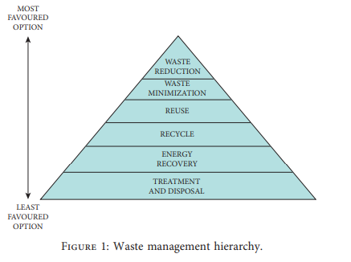

***Source from google***

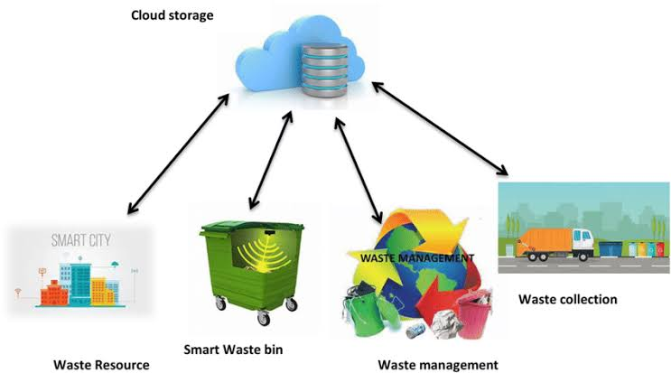

**Smart waste management system**

**3.References**

A Survey on Garbage Collection and Monitoring System for Smart cities using IOT Neha shinde1, Sayli Bhambre2, Shraddha Thakur3, Varsha Devkule4 1,2,3,4Dept of Computer Engineering, Terna Engineering College,Nerul,Navi Mumbai.

Smart waste management using Internet of Things: A survey

KN Fallavi, V Ravi Kumar, BM Chaithra

2017 International Conference on I-SMAC (IoT in Social, Mobile, Analytics and Cloud)(I-SMAC), 60-64, 2017.

IoT-based smart waste bin monitoring and municipal solid waste management system for smart cities

Tariq Ali, Muhammad Irfan, Abdullah Saeed Alwadie, Adam Glowacz

Arabian Journal for Science and Engineering 45 (12), 10185-10198, 2020.

A facilitating framework for a developing country to adopt smart waste management in the context of circular economyFeroz Khan, Yousaf Ali

Environmental Science and Pollution Research 29 (18), 26336-26351, 2022.

The state of art: Smart cities in India: A literature review report

R Ramaswamy, S Madakam

International Journal of Innovative Research and Development, II 12, 115-119, 2013.

Smart waste management system using IoT

V Pavan Sankeerth, V Santosh Markandeya, E Sri Ranga, V Bhavana

International Conference on Inventive Computation Technologies, 661-668, 2019.

Smart Garbage Segregator and IoT Based Waste Collection system

Mrigank Goel, Amogh Harsh Goyal, Preeti Dhiman, Vikas Deep, Purushottam Sharma, Vinod Kumar Shukla

2021 International Conference on Advance Computing and Innovative Technologies in Engineering (ICACITE), 149-153, 2021.

Internet of things-based urban waste management system for smart cities using a Cuckoo search alogorithm.